PROJECT DESIGN PHASE

Date | 02-11-2025
Team ID | NM2025TMFD05004
Project name | Laptop Request Catalog item Using Service Now

Introduction to Design Phase:
The design phase of the Laptop Request Catalog Item project in ServiceNow serves as a bridge between the requirement analysis and the actual system implementation. Its primary objective is to convert the gathered business and functional requirements into a detailed, structured design that defines how the catalog item will operate within the ServiceNow environment.
STEPS:
1.Creation of new update set:
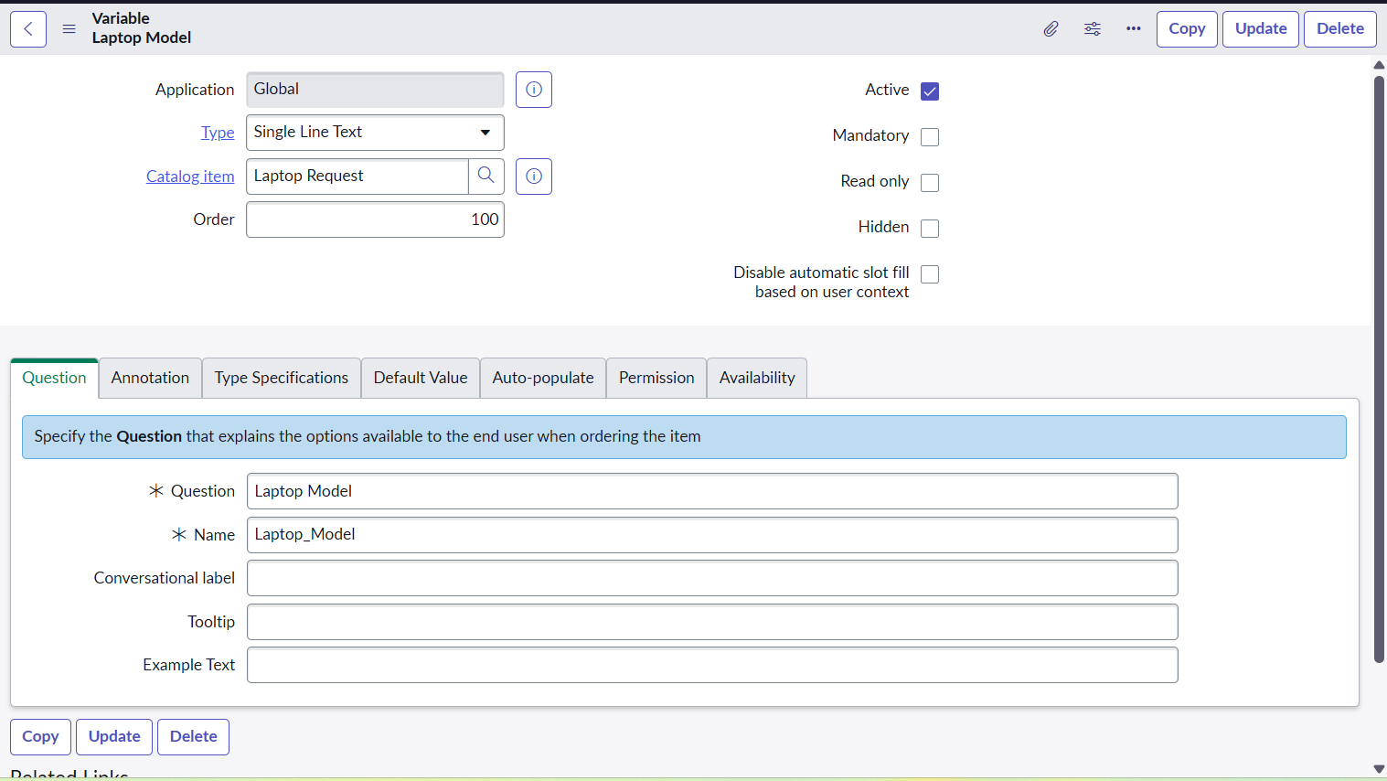
Go to All >> In the filter search for Local Update set > click on New.
Enter the Details in laptop
2.Table creation:
Catalog Items in table:
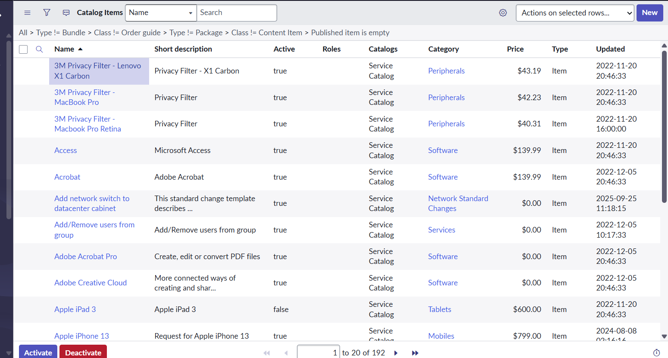
Laptop Request table:

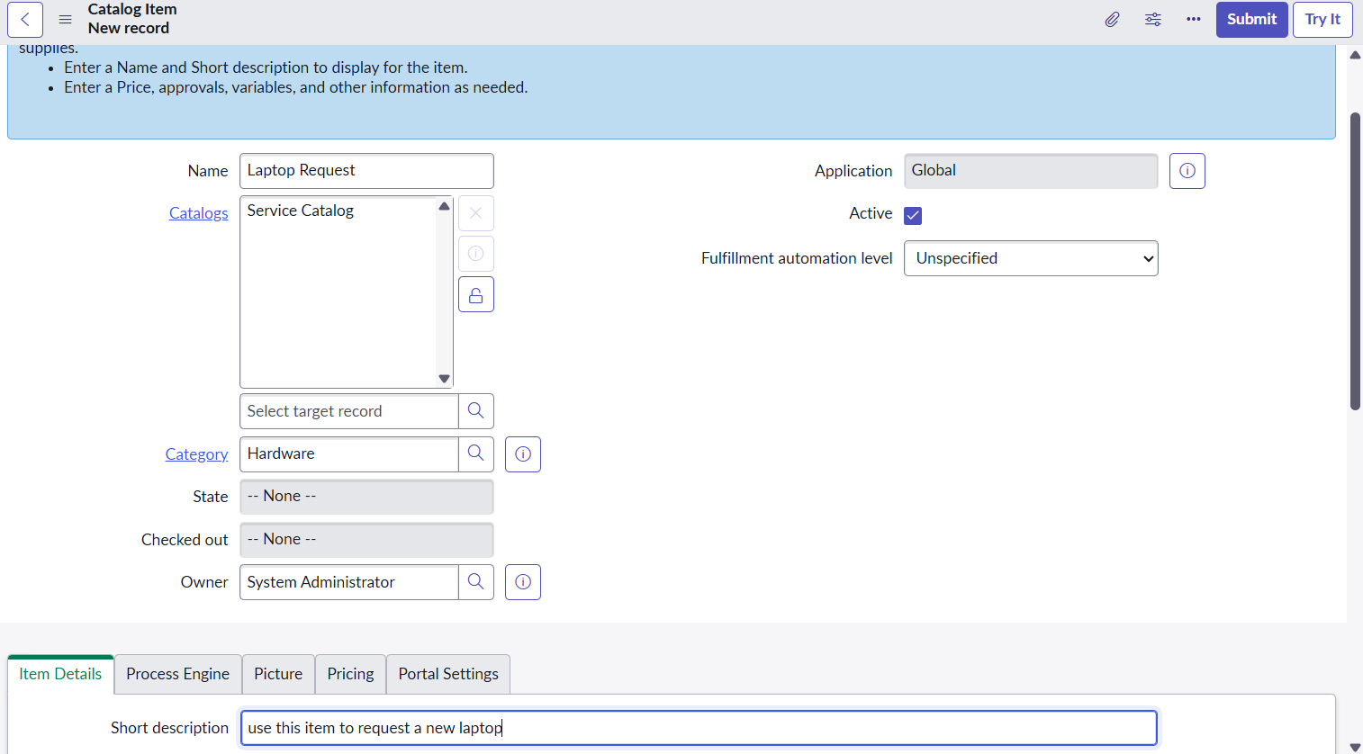

3. Add Variables:
- Go to All >> In the filter search for Relationships >> Open Relationships
- Click on New.
- Enter the details:

Variables : Laptop Model
Type: Single line text
Name: laptop_model
Order:100

Variables : Accessories Details
Type: Multi line text
Name:accessories_details
Order:400
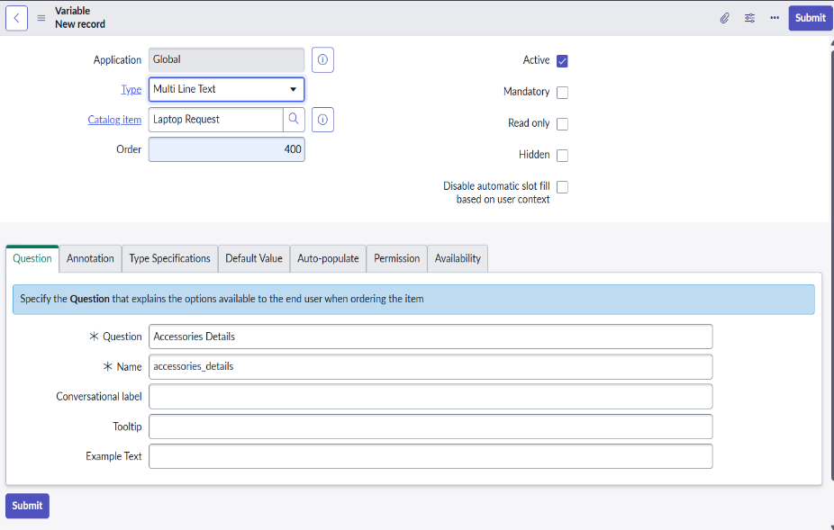

4.Click Save

4.Creation of Business Rules:
- Go to All >> In the filter search for Service catalog.
- Under catalog Definition Laptop Request then click on New.
- Enter the Details:

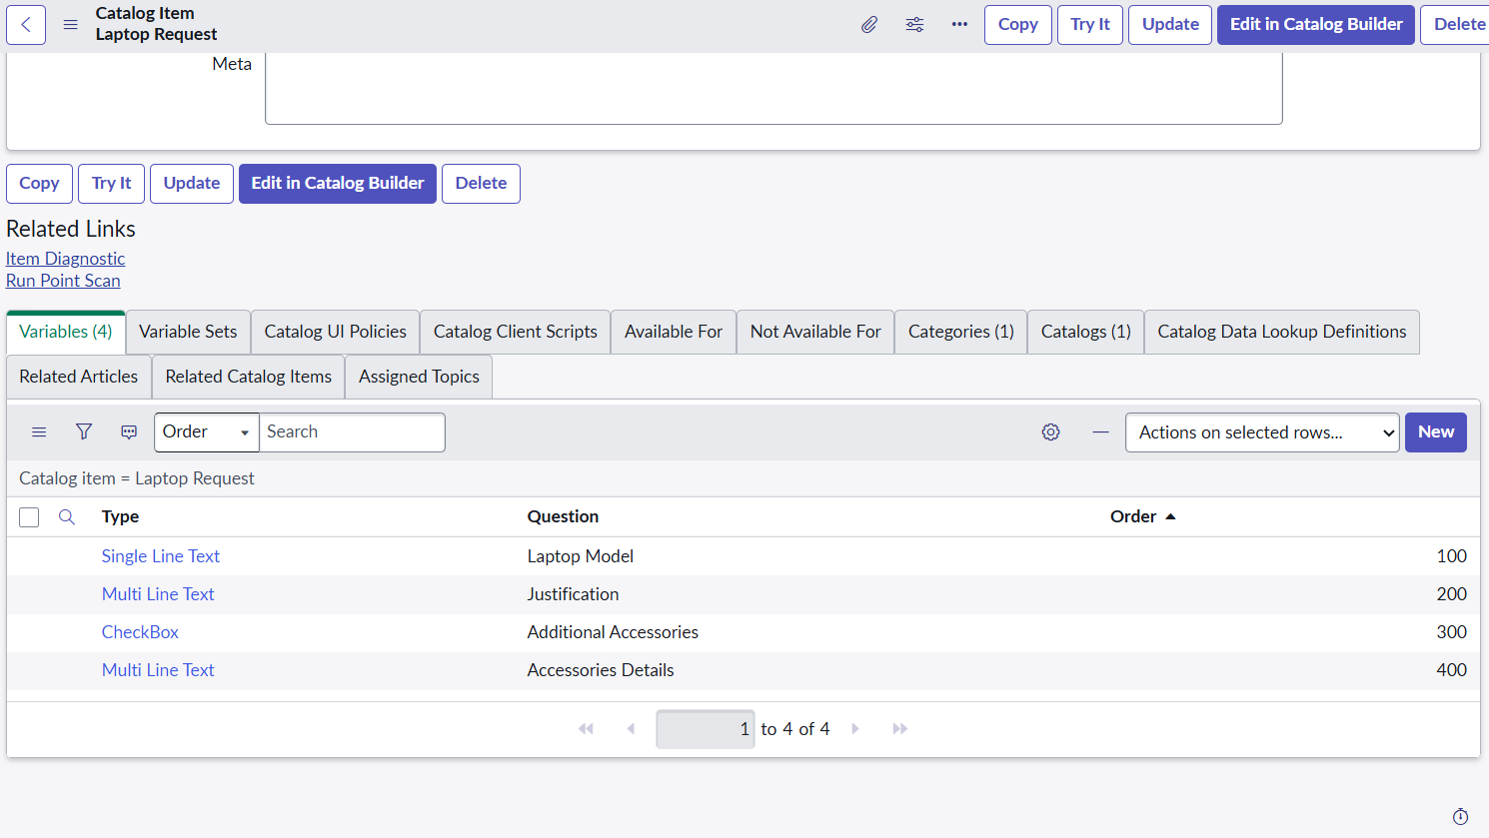
Creation of Ui action:
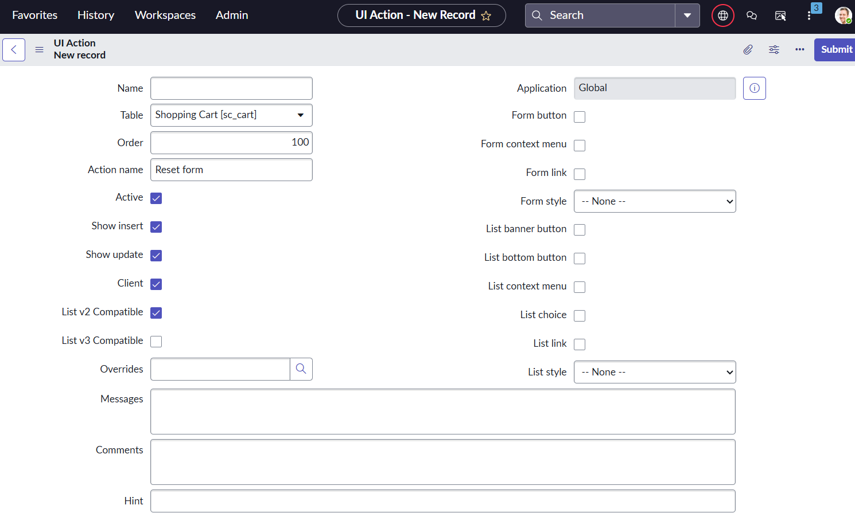

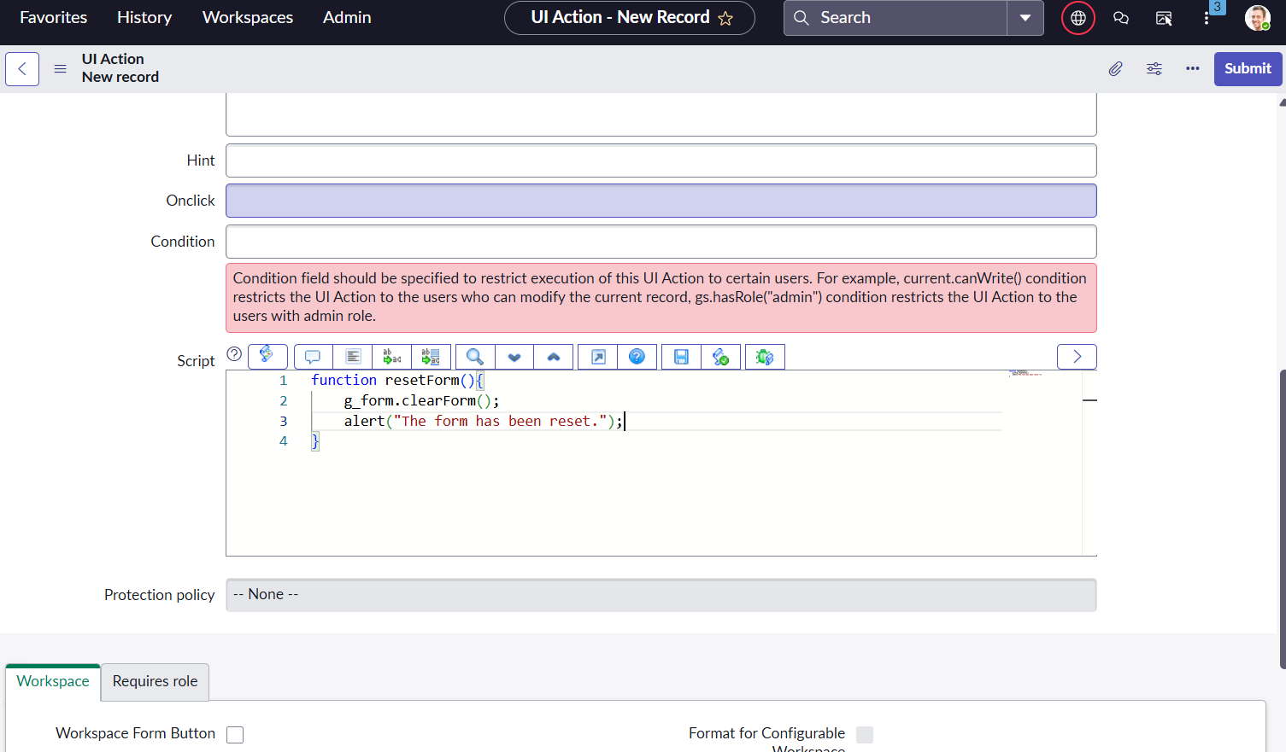

Conclusion of Design Phase:
The design phase has effectively transformed analytical insights from the laptop request process into a well-defined ServiceNow catalog design. The outcome provides a clear blueprint for development, ensuring that the implemented solution will streamline laptop.

